***Experiment 6 Output***

**Aim:** The experiment configures load balancing and auto-scaling using **AWS CLI, LocalStack, Docker,** and **Nginx**. It simulates cloud traffic distribution across instances for efficient workload management. The setup demonstrates scalable deployment in a local cloud environment.

***Pulling Nginx for Execution***

***Creating VPC***

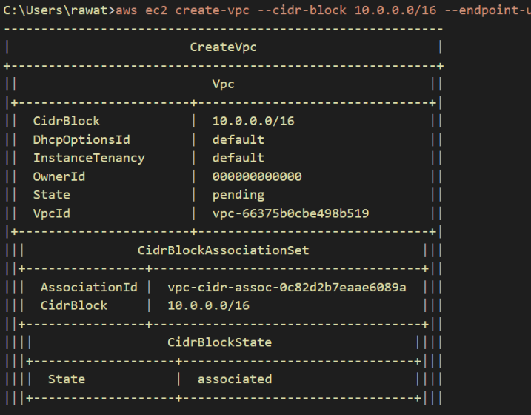

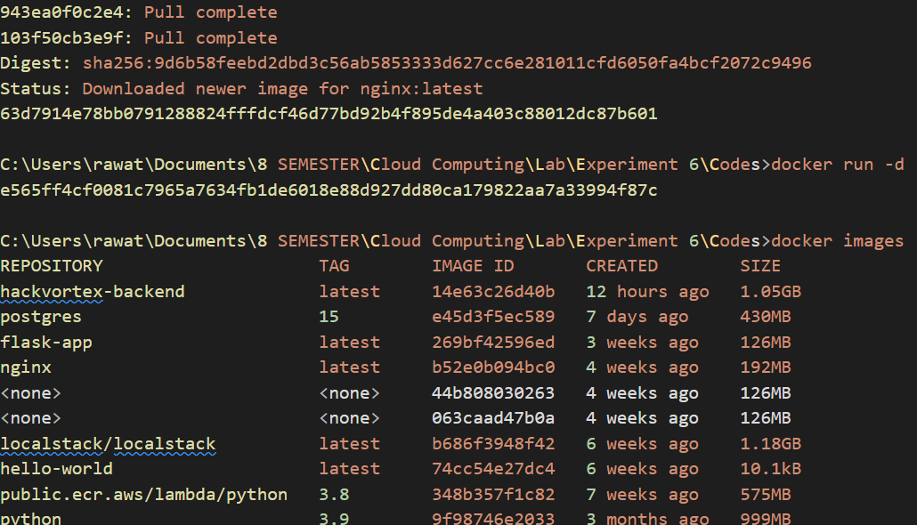

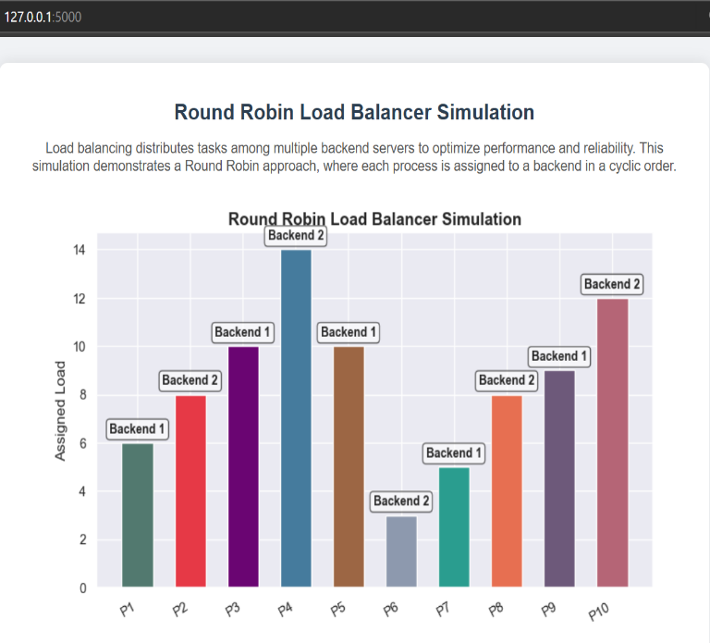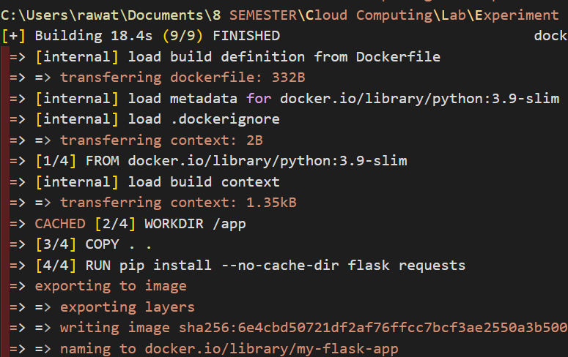

***Fig 2: Docker Pulling and Output Image***

**Fig 1: VPC Setup**

***Running Flask Load balancing App***

***Output with graph showing processes***

***Fig 3: Flask App***

***Fig 4: Flask App Output***